**Video link:** [**https://drive.google.com/file/d/13QsixFChcrCLYb4XLsODZkamWQmzQznh/view?usp=sharing**](https://drive.google.com/file/d/13QsixFChcrCLYb4XLsODZkamWQmzQznh/view?usp=sharing)

**Q1) Sort the list of ages, find min and max, average, median and range**

**#Importing library called statistics which helps in calculating mathematical data**

**import statistics  
ages = [19, 22, 19, 24, 20, 25, 26, 24, 25, 24]**

# Sorts age list in ascending order by default

**ages.sort()  
print ("Sorted age:", ages) # Displays sorted values**

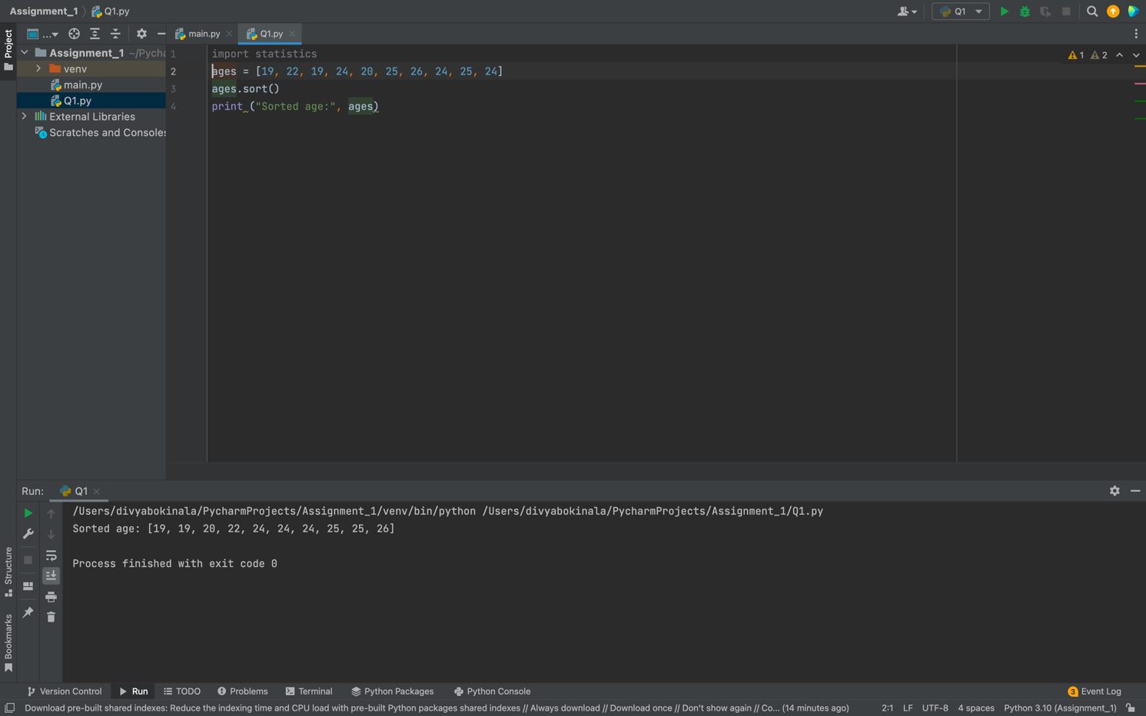

# Minimum age

**# Displays min value as we used min() method**

**print ("Min:", min(ages))**

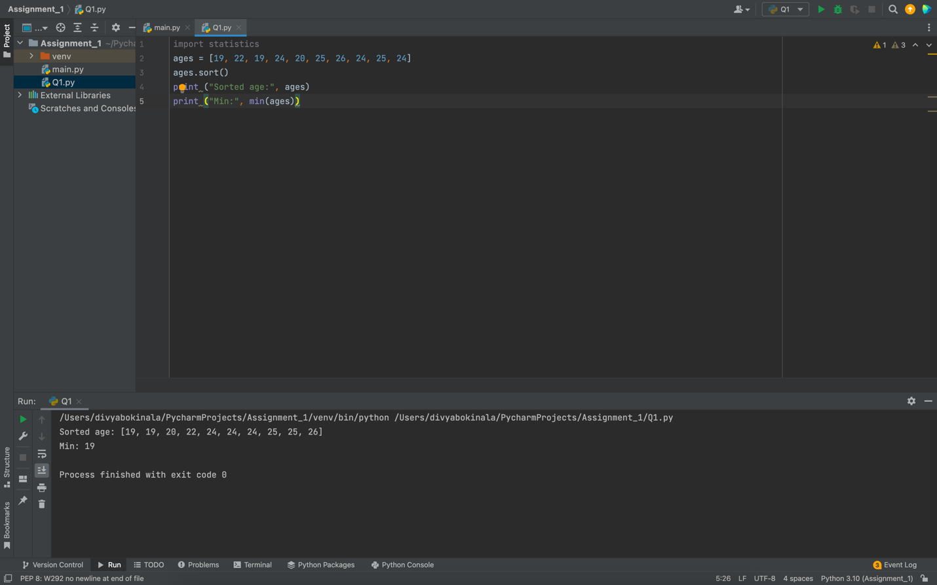

# Maximum age

**# Displays max value as we used max() method**

**print ("Max:", max(ages))**

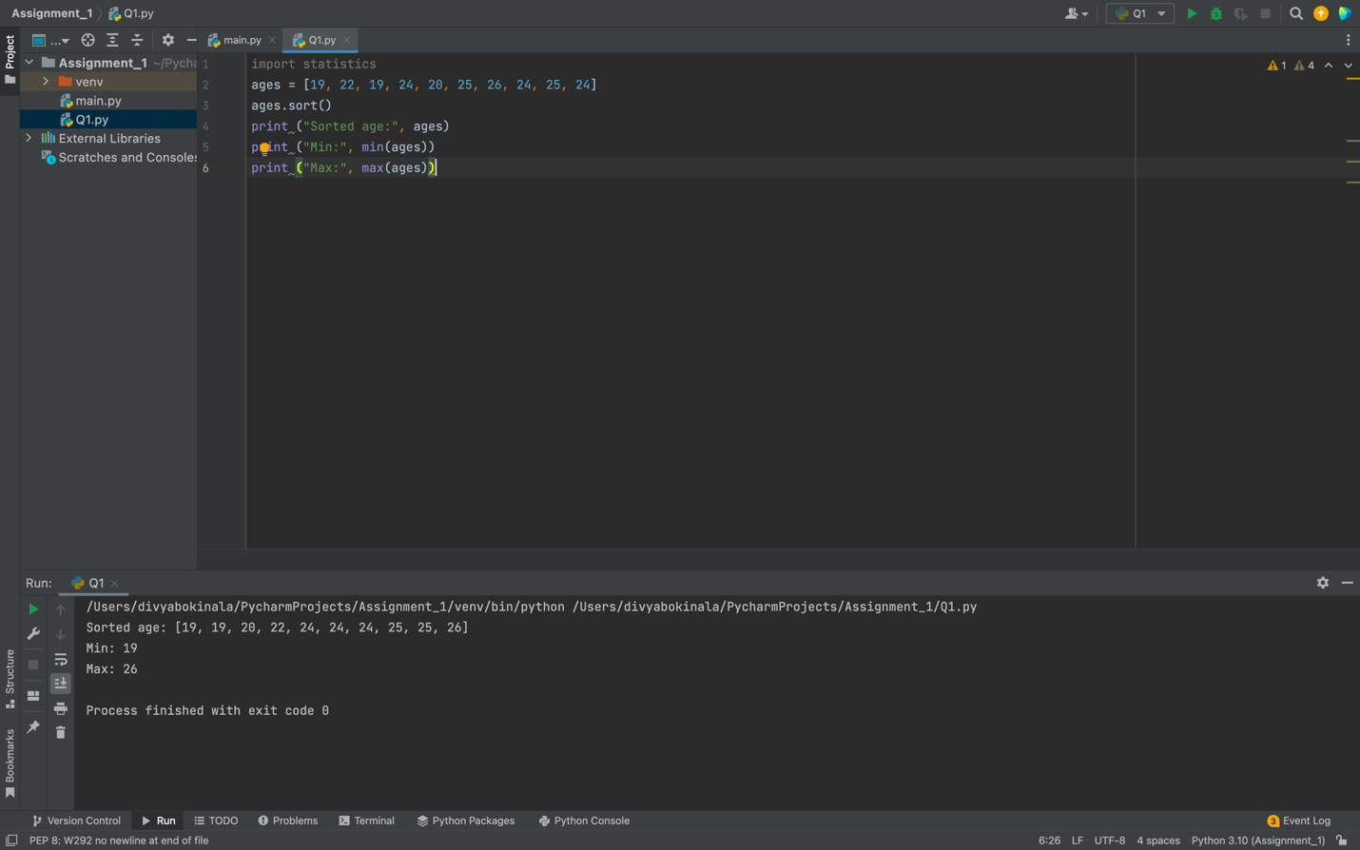

**# Adding again min and max values so we use append() method to insert values to the list**

**ages.append(min(ages))**

**ages.append(max(ages))**

**print ("Added min and max values again:",ages) #Displays the list again with new values**

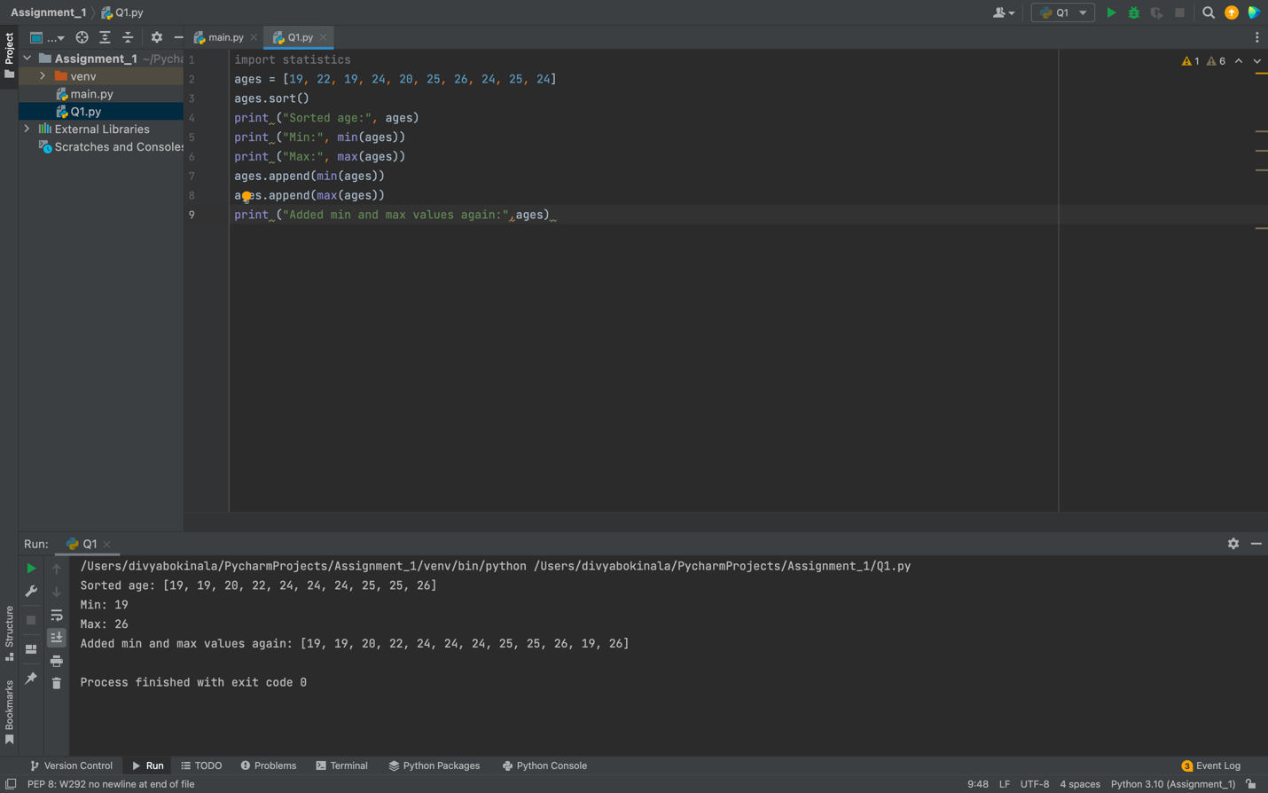

# Median (one middle item or two middle items divided by two, as we imported statistics library it calculates easily and provides the opt)

**mdn_age = statistics.median(ages) print ("Median:", mdn_age)**

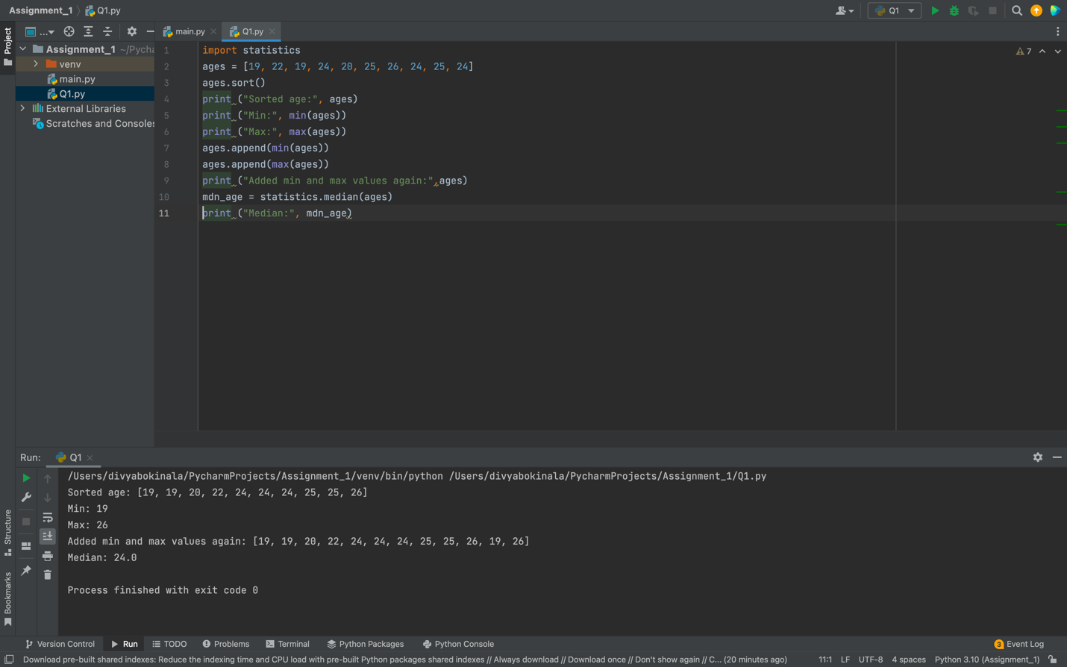

# Average age  
**average= sum(ages)/len(ages) print ("Avg = ", average)**

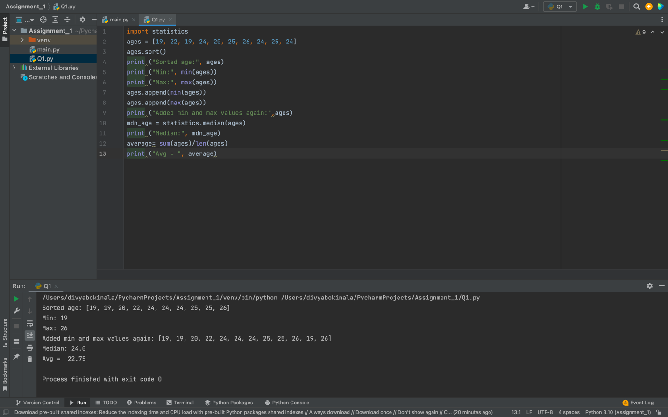

# Range

**rng=max(ages)-min(ages) print ("Range = ", rng)**

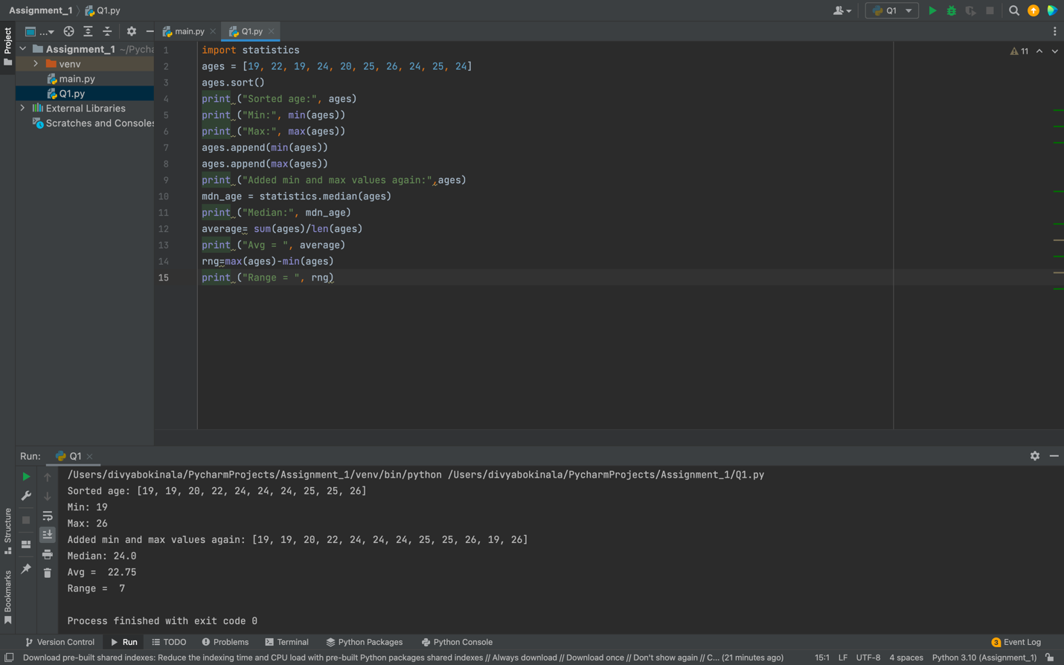

**Q2) Create a dictionary**

# Dog dictionary is created with given key and values

**dog = {'name':'Tommy','color':'white','breed':'husky','legs':'4','age':'2'} print ("Dog Dictionary Created:",dog)**

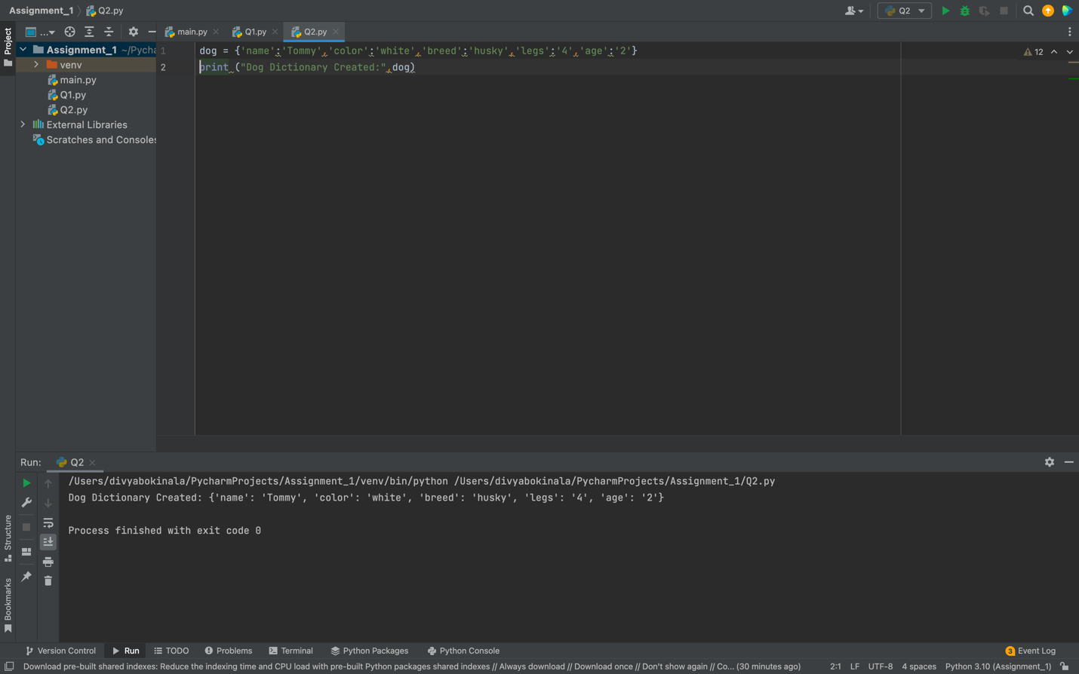

# Student dictionary is created with given key and values

**student = {'first_name':'Srujana','last_name':'Makutam','Gender':'Female','age':'22','marital_status':'si ngle',**

**'skills':'dancer','Country':'India','City':'Hyderabad','Address':'1/180'} print ("Student Dictionary Created:",student)**

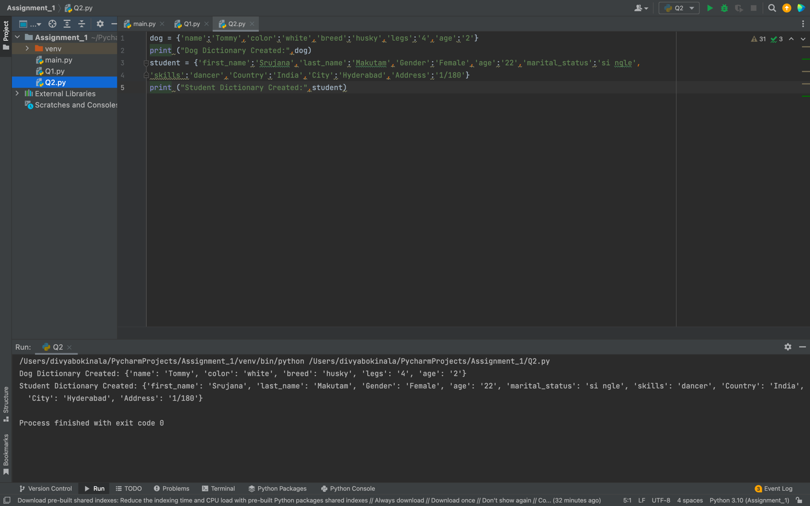

# Create another dictionary for skills  
**skills = {'dancer':'1','singer':'2','coder':'3'}**

**print ("Skills Dictionary Created:",skills)**

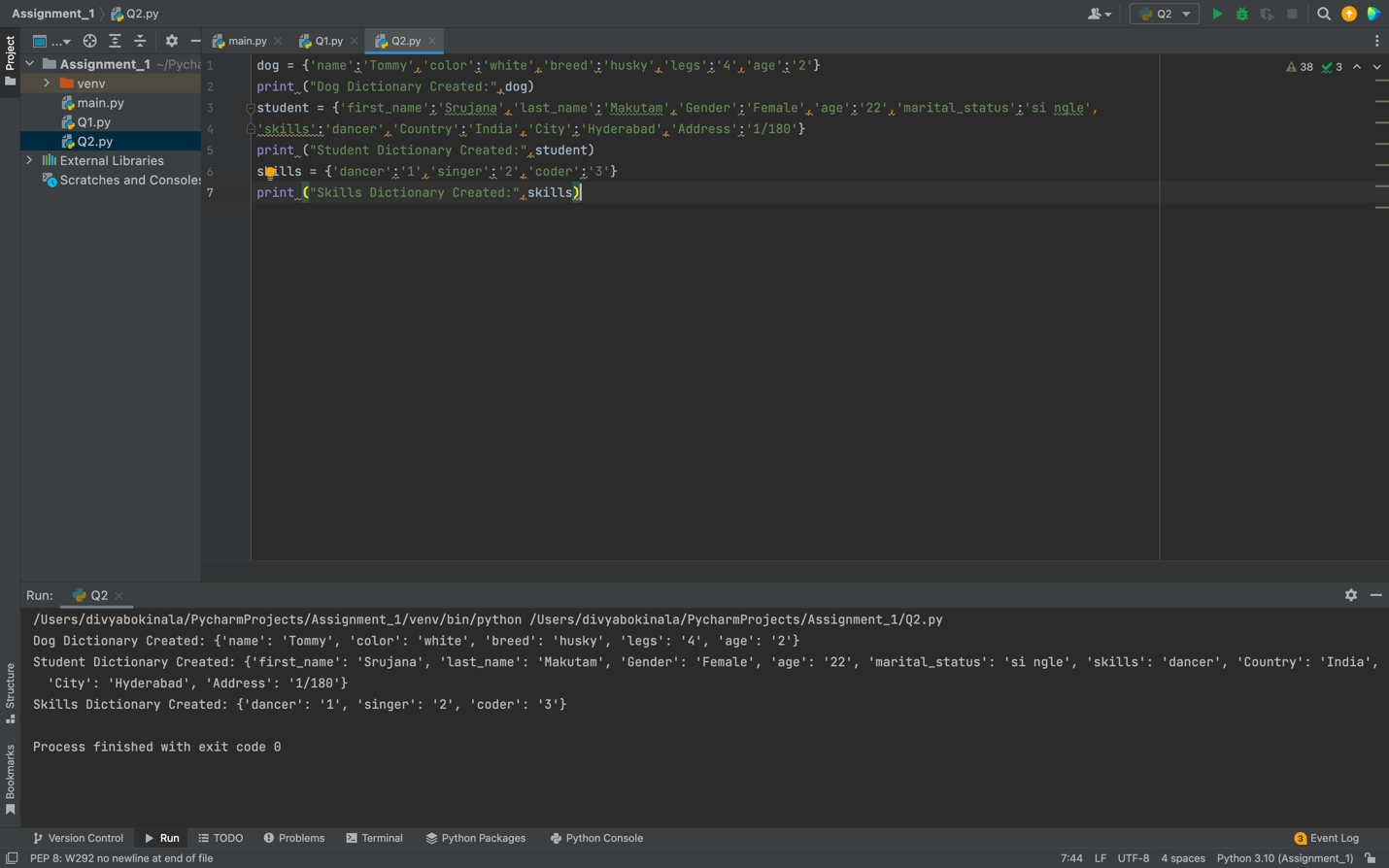

# Find the length of student dictionary

**print ("Length of student:", len(student))**

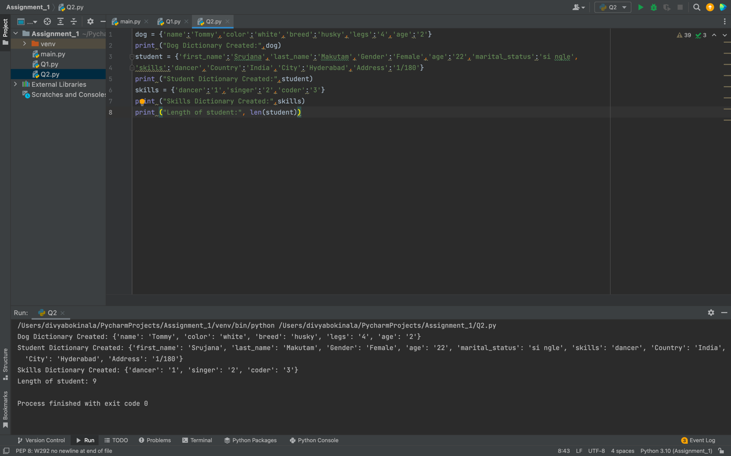

# Check the datatype of skills

**print ("Datatype fo skills:",type(skills))**

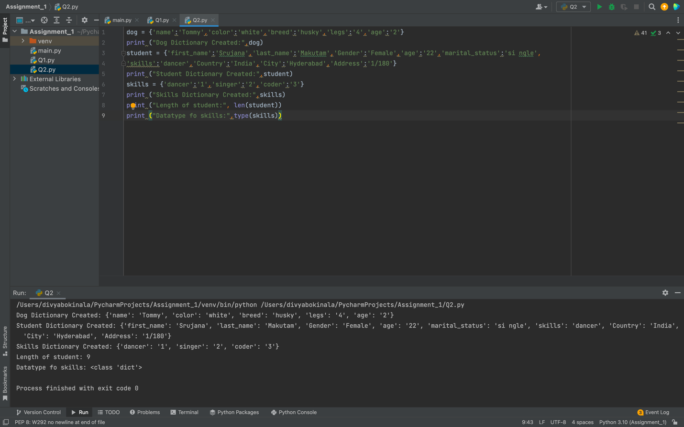

# Get values of skills dictionary

**print ("Values of skills:",skills.values())**

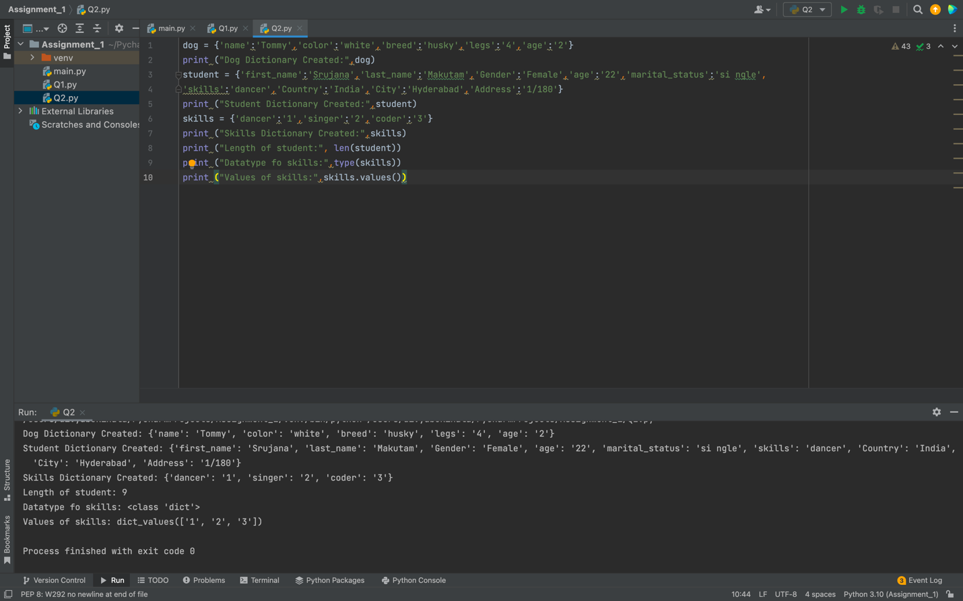

# Add one item to skills

**skills['artist'] = 4  
print ("New skill added:",skills)**

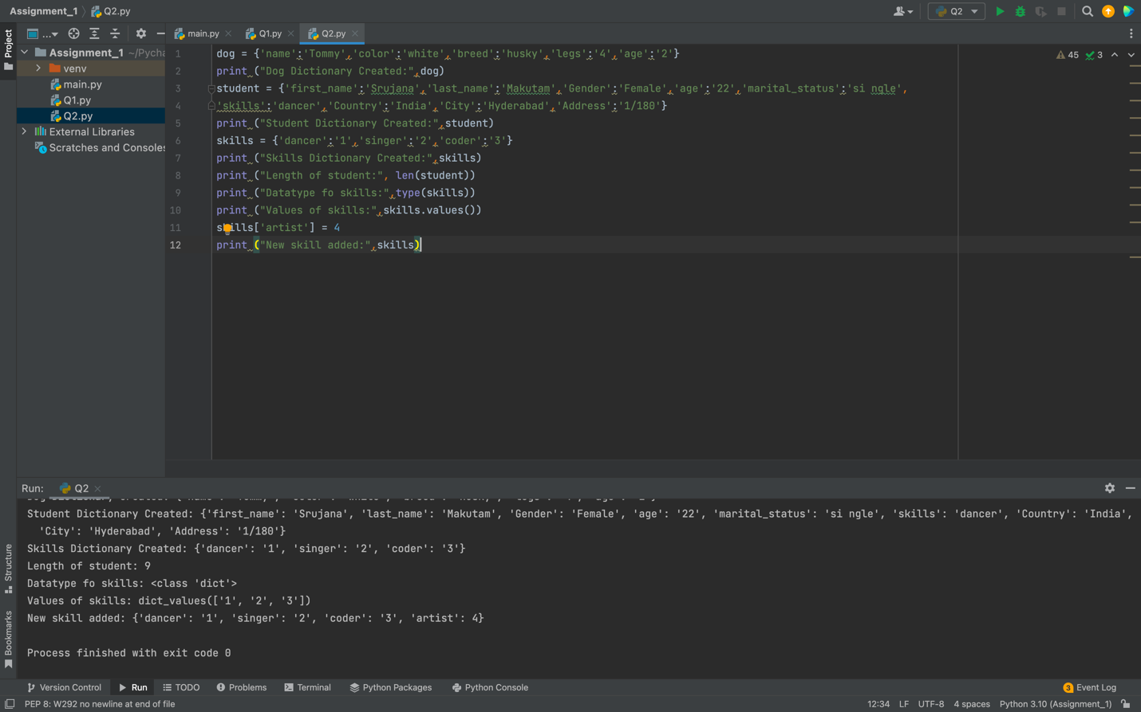

# Get dog and student key and values

**print ("Dog keys:",dog.keys())  
print ("Student values:",student.values())**

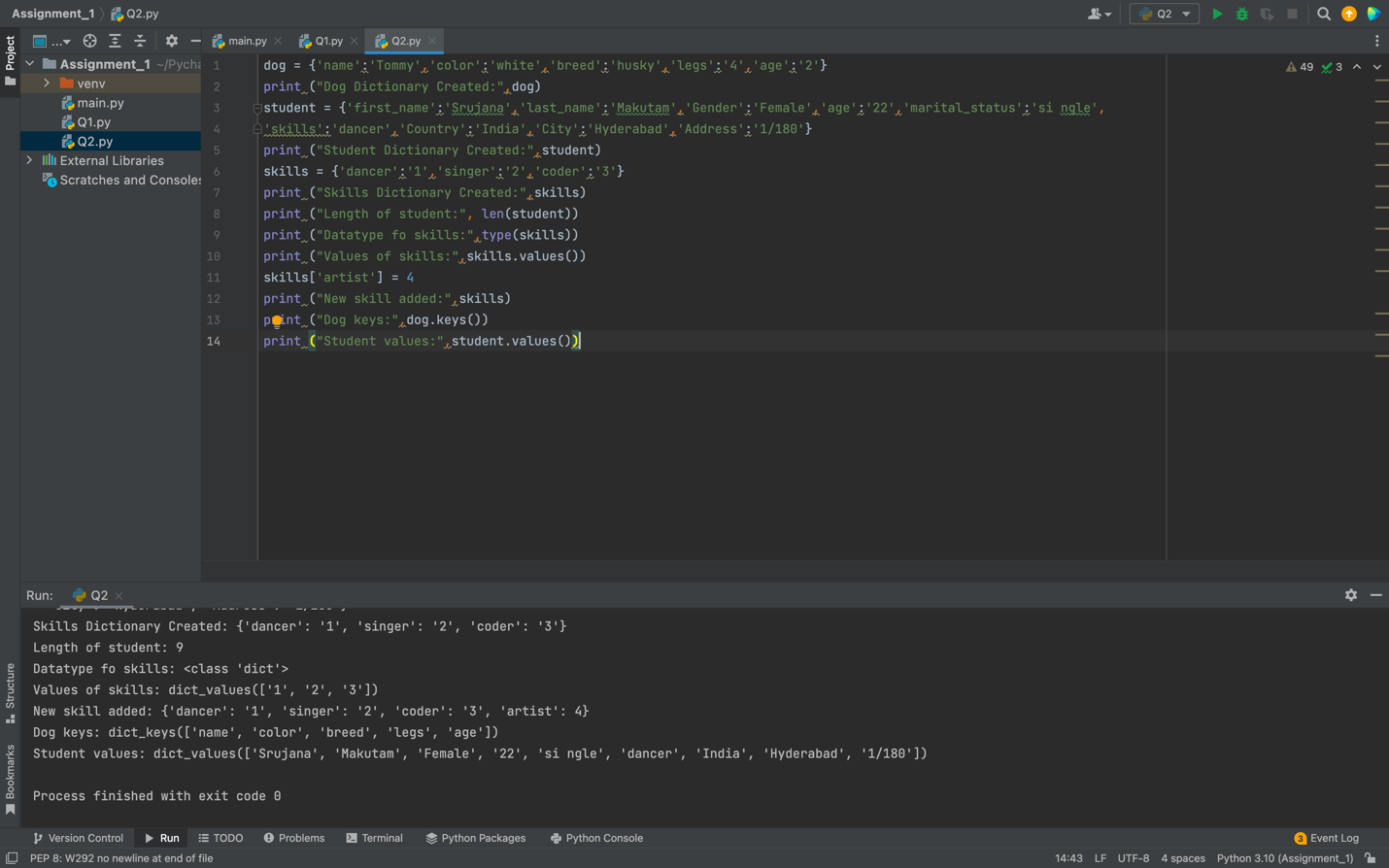

**Q3) Create tuple of sisters and brothers**

**my_sisters = ('Sanjana', 'Sheethal','Shivani','Spoorthi')  
my_brothers = ('Akhil','Suchith','Vandith','Vaishnav')**

# Create another tuple as siblings and join the sister’s and brother’s tuple

**siblings = my_sisters + my_brothers**

# Displays siblings’ output and length of siblings  
**print("Siblings:", siblings)  
print("Length of Siblings:", len(siblings))**

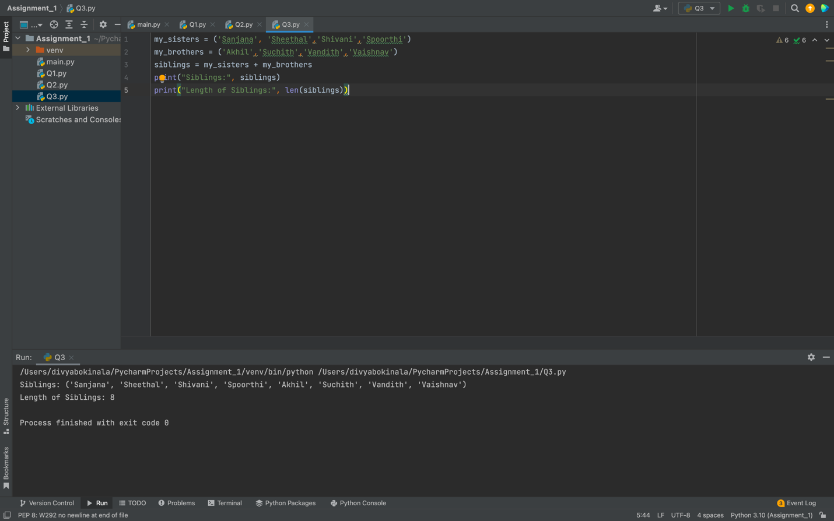

# Create another tuple as family_members and add father and mother name to it

**family_members = siblings + ('Srinivas','Susmitha')**

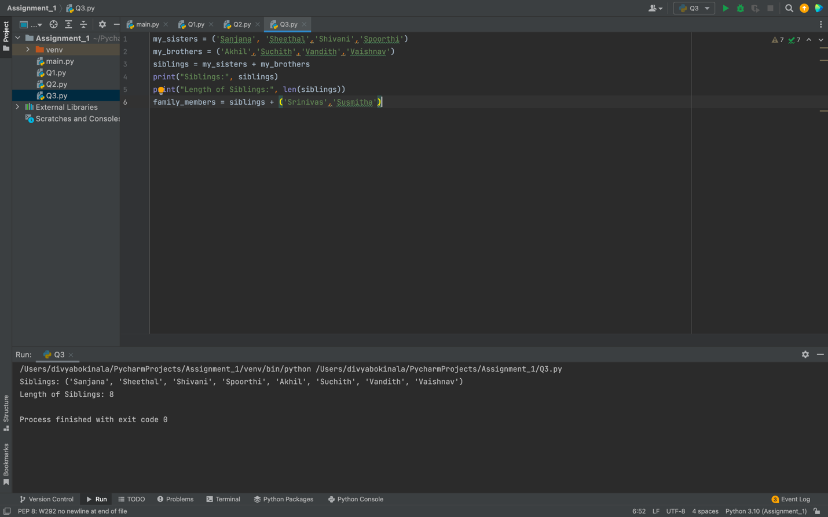

# Displays family_members output **print("Family_members:",family_members)**

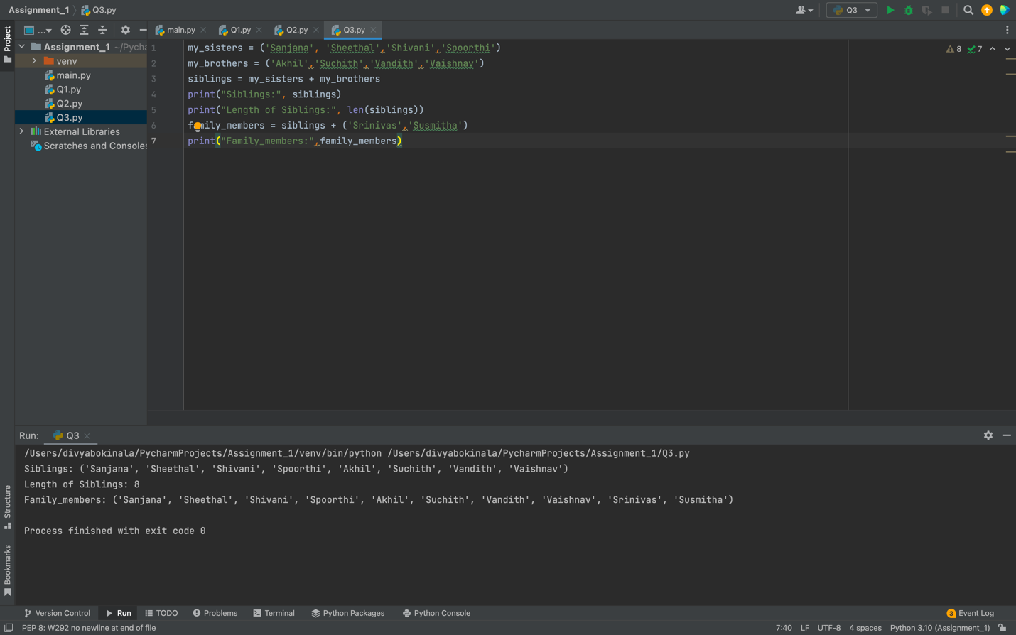

**Q4) Length of the set  
it_companies = {'Facebook', 'Google', 'Microsoft', 'Apple', 'IBM', 'Oracle', 'Amazon'} print("Length of it_companies:", len(it_companies))**

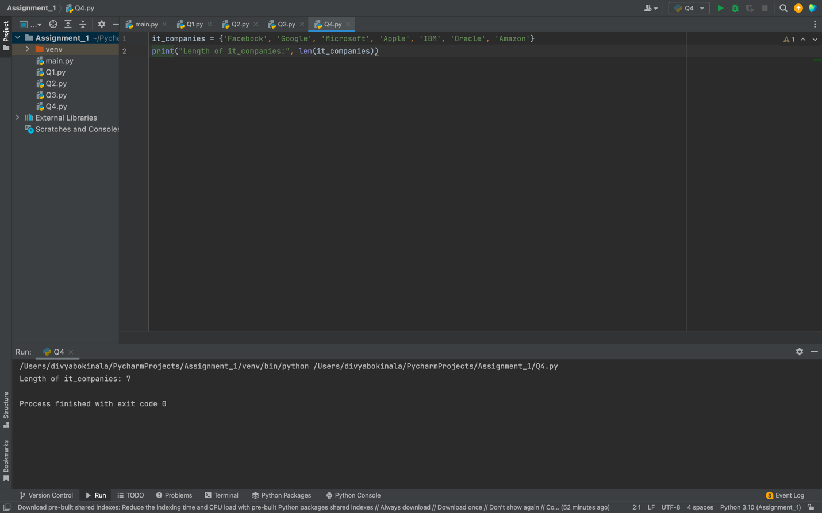

#Add twitter  
**it_companies.add('Twitter')  
print("After adding another item:",it_companies)**

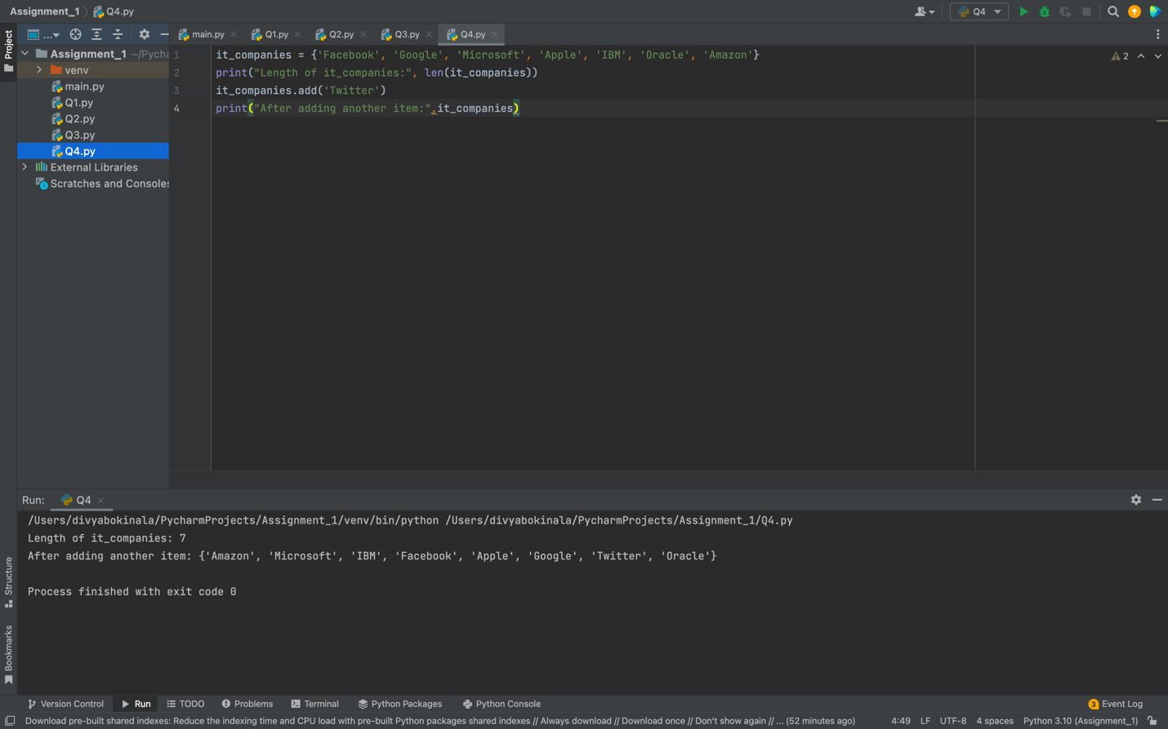

#Add multiple it_companies **it_companies.update({'Infosys','Capgemini','Wipro','TCS'})  
print("After adding multiple items:",it_companies)**

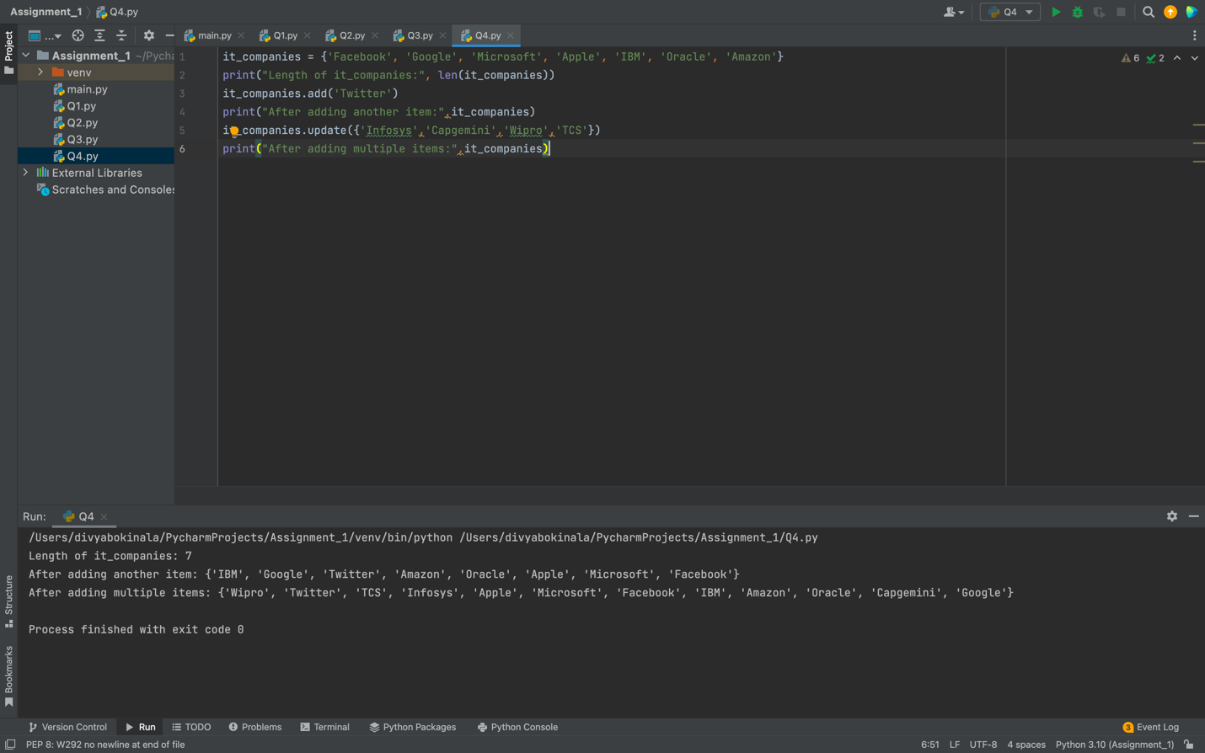

#Remove  
**it_companies.remove('TCS')  
print("After removing one company:",it_companies)**

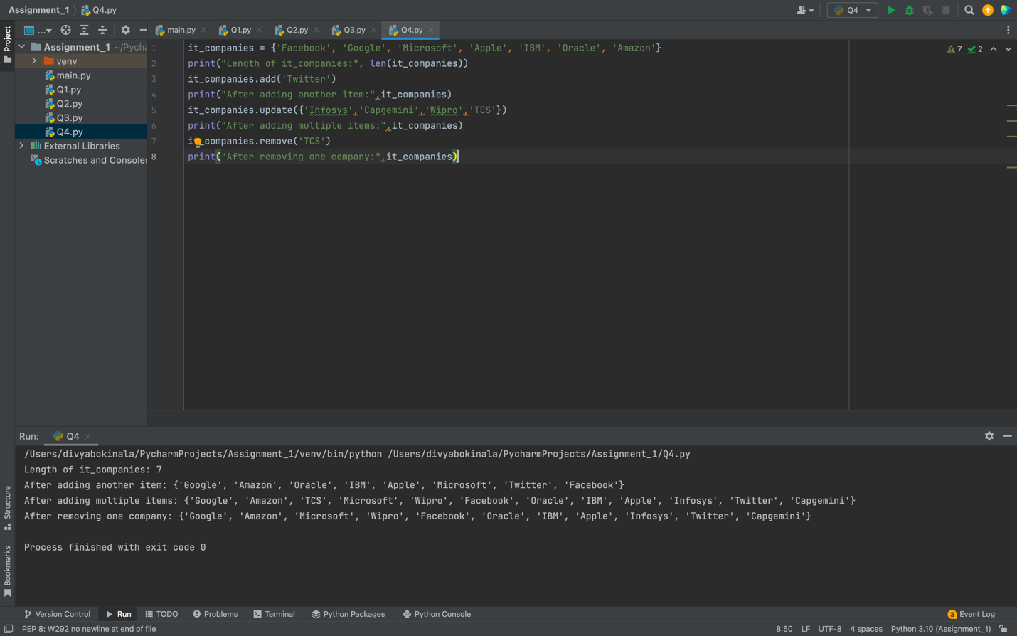

#Discard  
**it_companies.discard('TCS')  
print("After discarding company:",it_companies)**

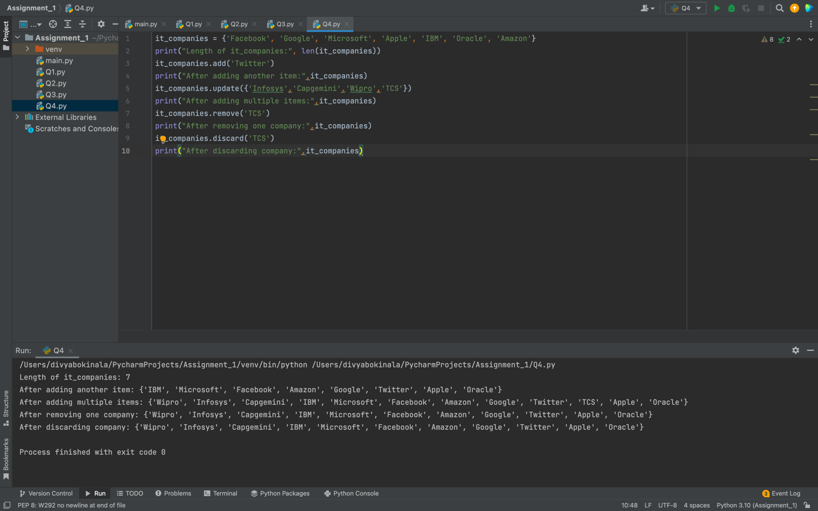

#Discard doesn't raise any error if any item is not present in the set  
#Join A & B  
**A = {19, 22, 24, 20, 25, 26}  
B = {19, 22, 20, 25, 26, 24, 28, 27}  
print("Join A and B:", A.union(B))**

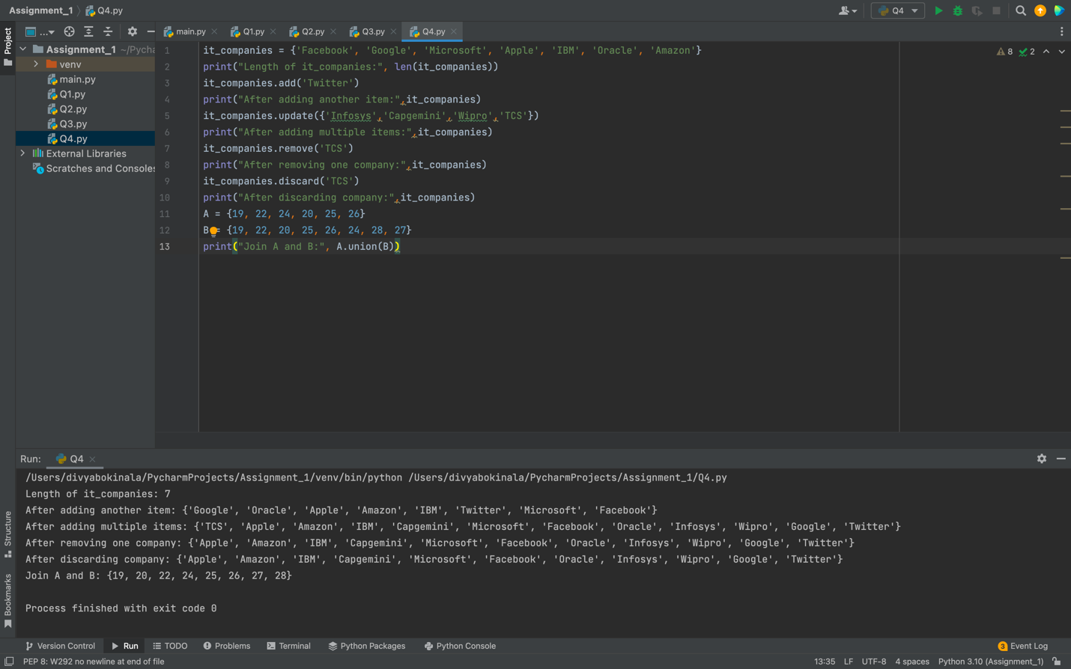

#Intersection  
**print("Intersection of A and B:", A.intersection(B))**

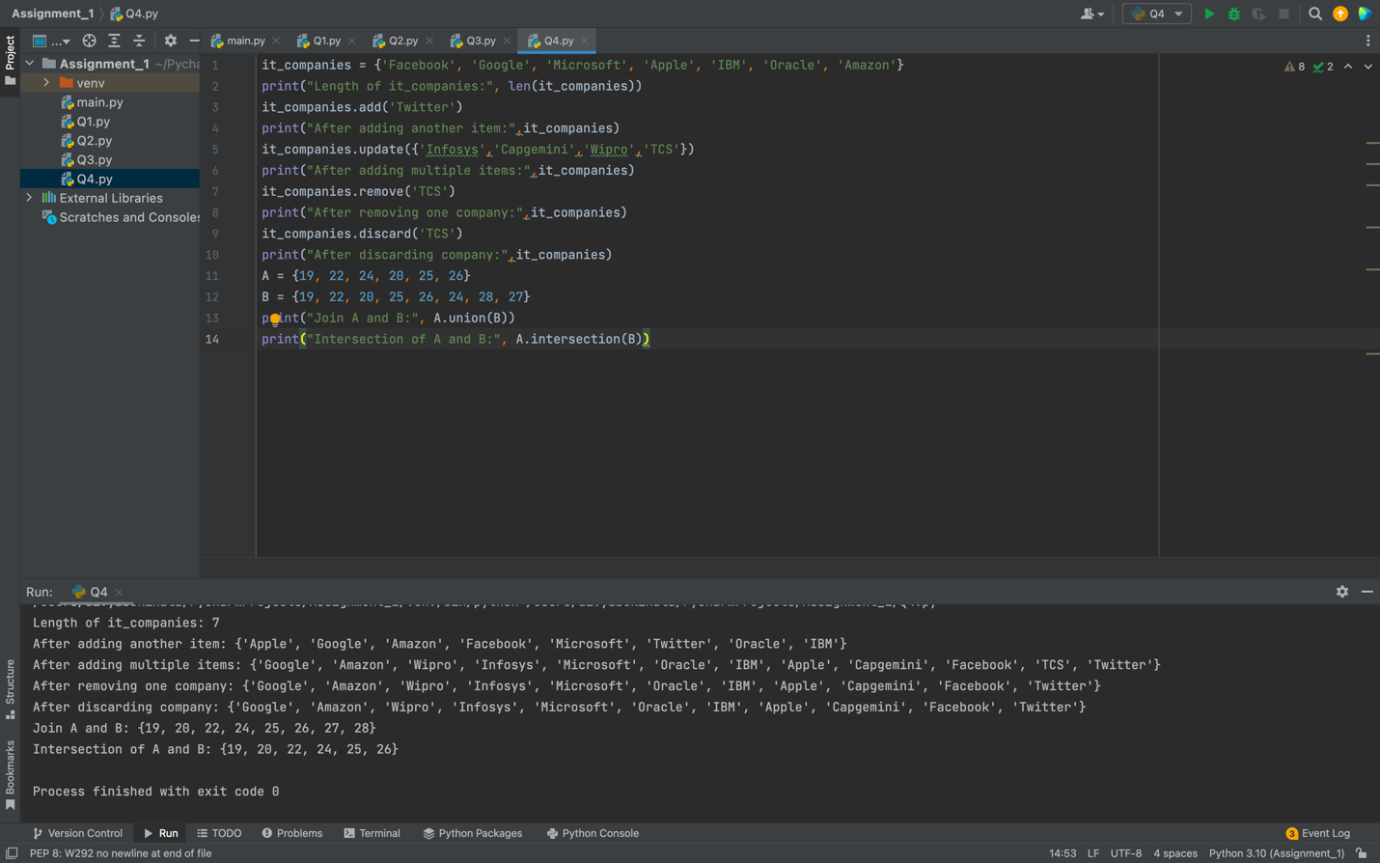

#Subset  
**print("Subset of A and B:", A.issubset(B))**

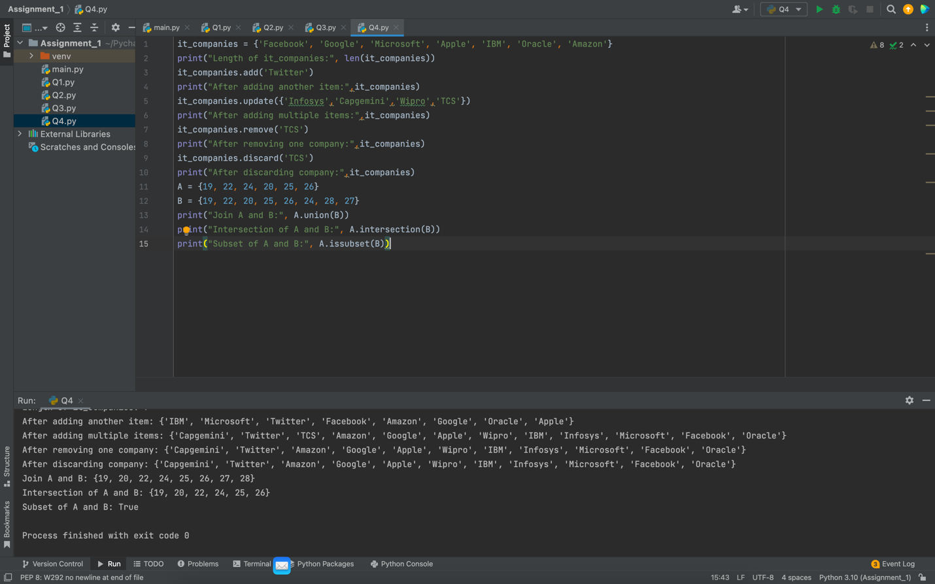

#Disjoint  
**print("Disjoint:", A.isdisjoint(B))**

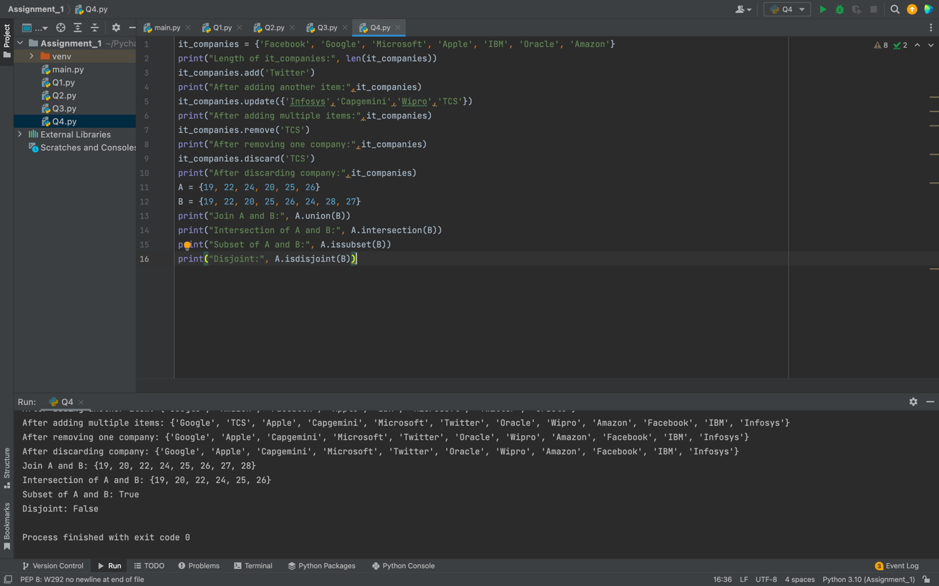

#Convert list to set  
**age = [22, 19, 24, 25, 26, 24, 25, 24]  
print("Converting list to set:", set(age))**

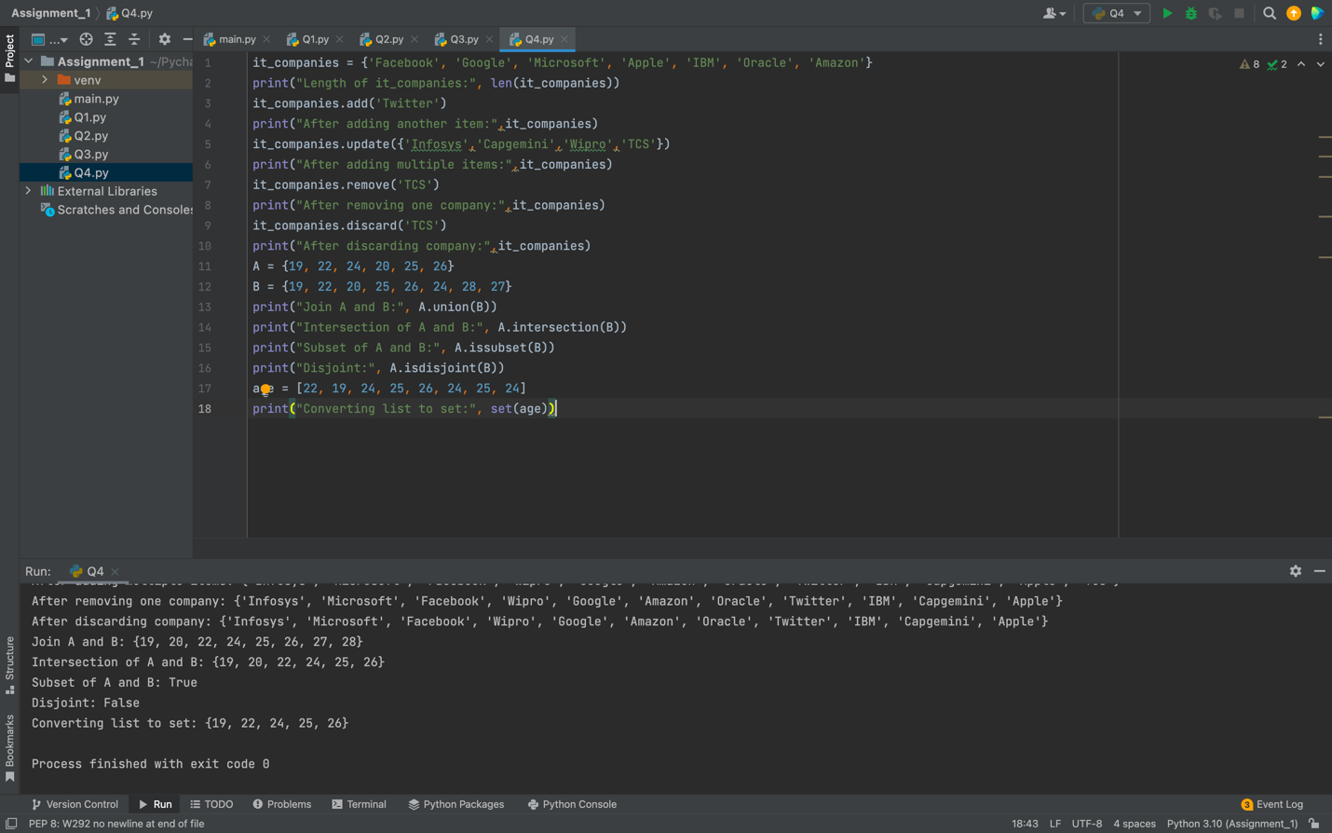

#Length of set  
**print("Length of set:",len(set(age)))**

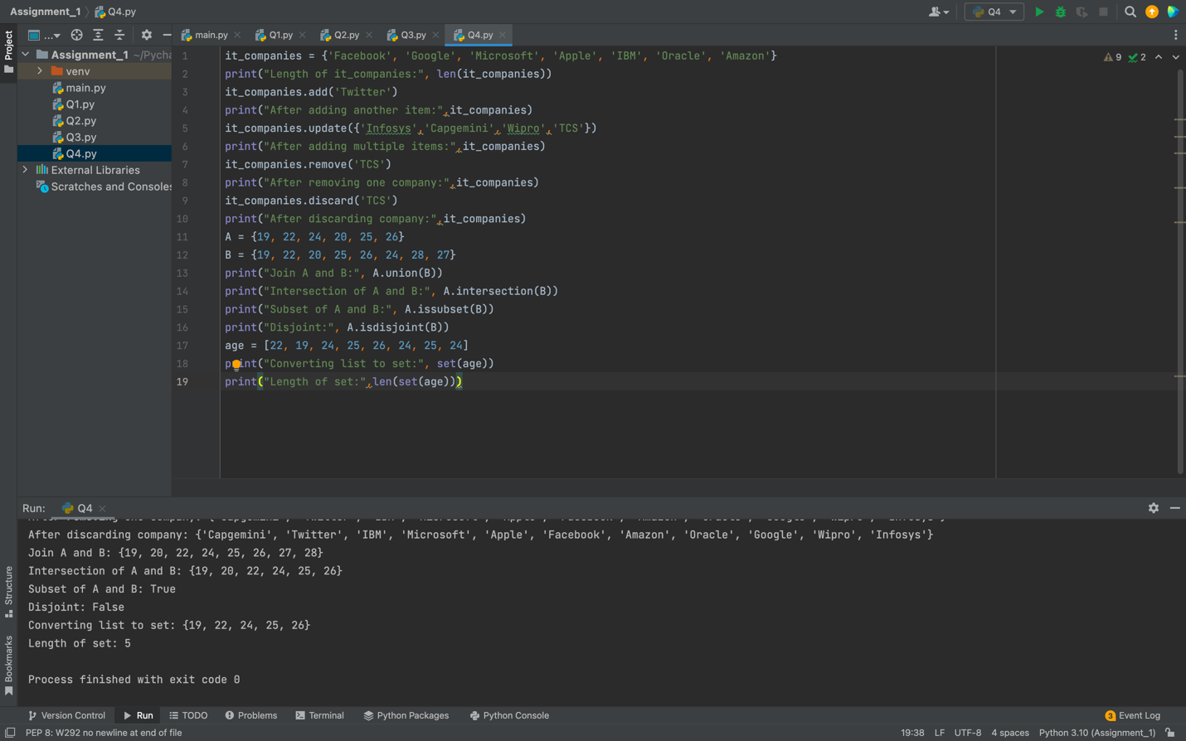

#Length of list

**print("Length of list:",len(age))**

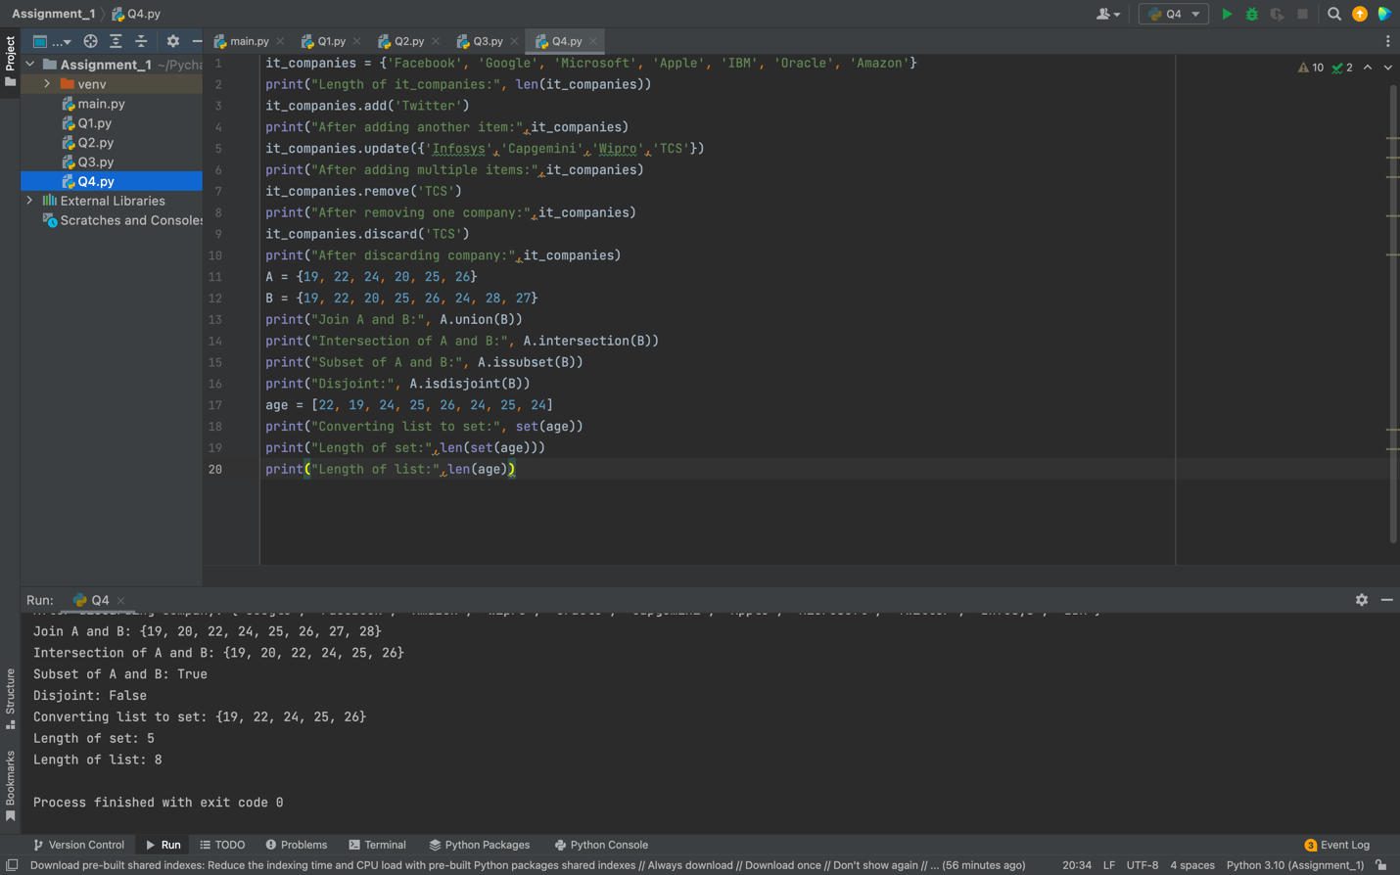

**#Symmetric diff- returns values which are not in common with other set print("Symmetric diff:",A.symmetric_difference(B))**

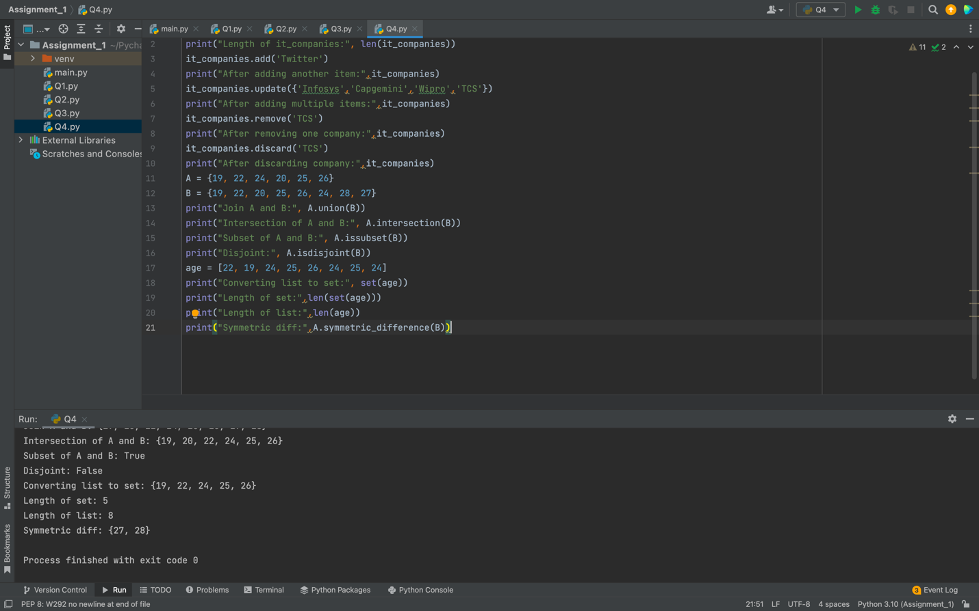

#delete set  
A.clear()  
print(A)  
B.clear()  
print(B)

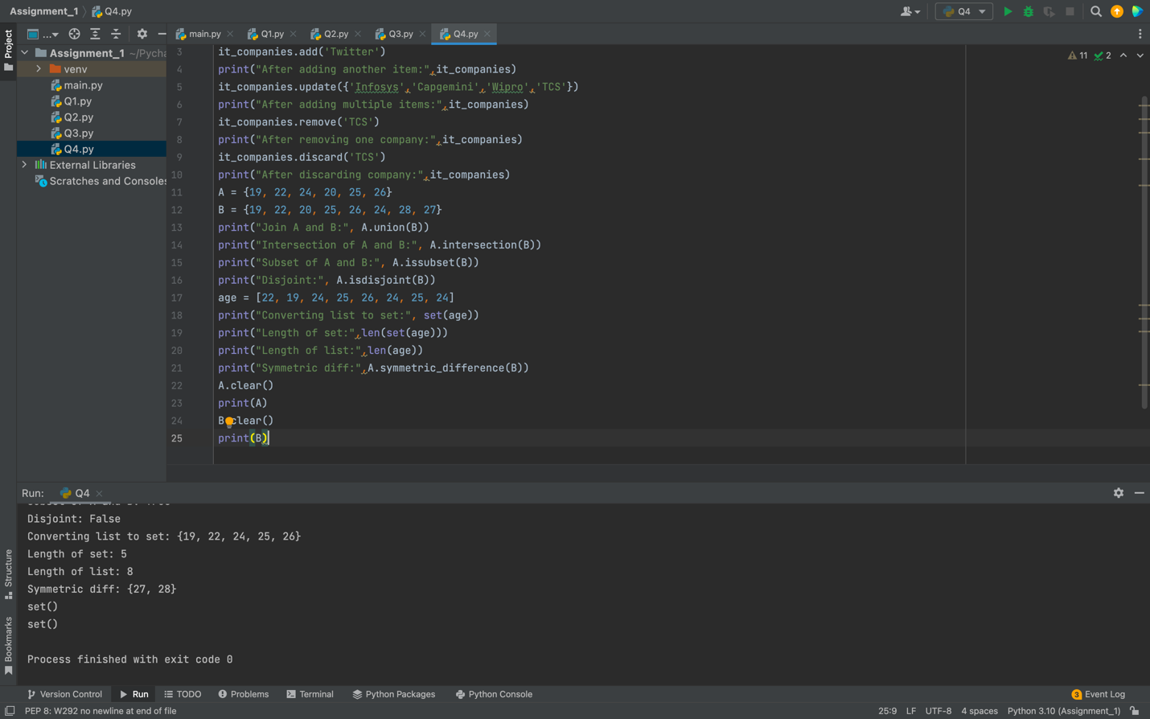

**Q5) Calculate area of circle and circumference of circle**

# Initialise r where r value can be read from user inpt

**r = int(input("enter r:"))**

# Calculate area of circle and circumference of circle

**_area_of_circle = 3.14*r*r  
_circum_of_circle = 2*3.14*r**

# Display area of circle and circumference of circle **print("Area of Circle:",_area_of_circle) print("Circumference of Circle:",_circum_of_circle)**

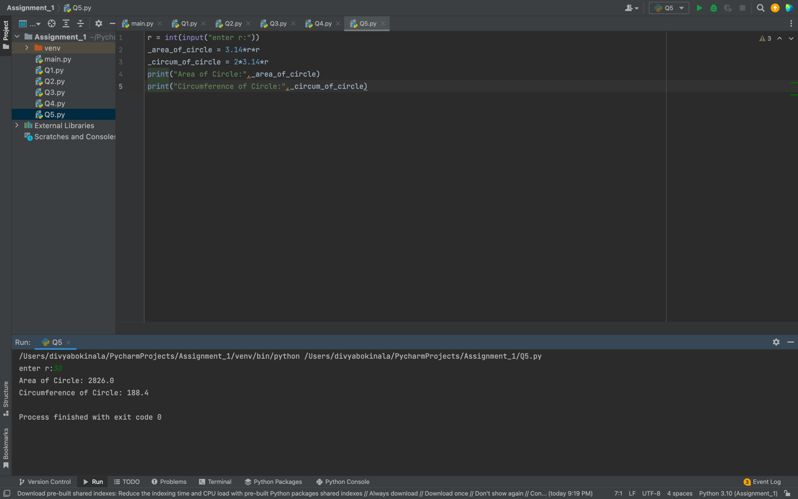

**Q6) Unique words using split method**

s ="I am a teacher and I love to inspire and teach people"

l=set(s.split(" "))

print(l)

print(len(l))

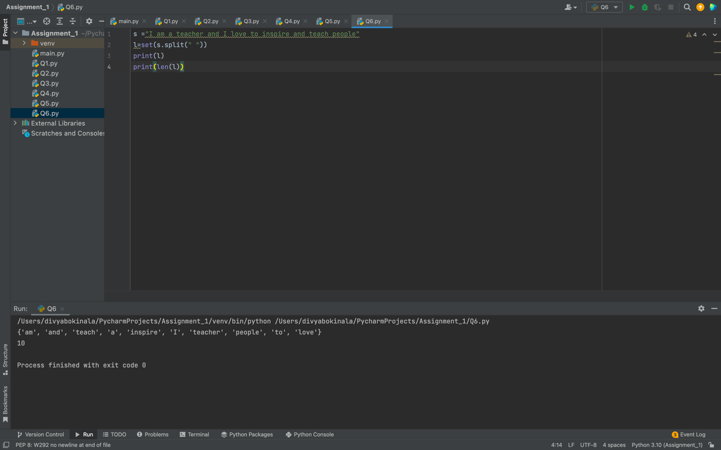

**Q7) Used tab and escape to display them in the given format**

**a= "Name\t Age\tCountry\tCity\t\nAsabeneh 250\tFinland\tHelsinki"**

**print(a)**

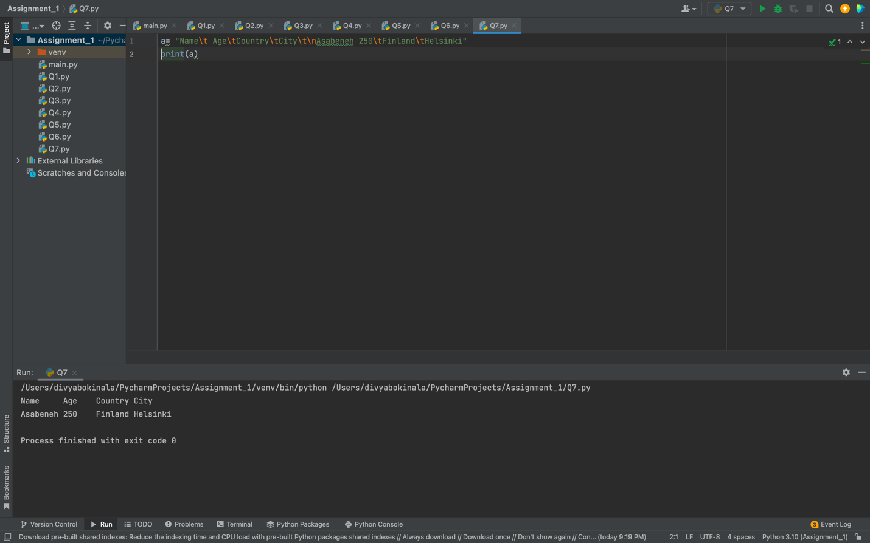

**Q8**) **Use the string formatting method to display the following:**

**#Using String format method  
print(f'radius = 10')  
print(f'area = 3.14*radius**2')**

**print(f'"The area of circle with radius {r} is {3.14*r*r} meters square"')**

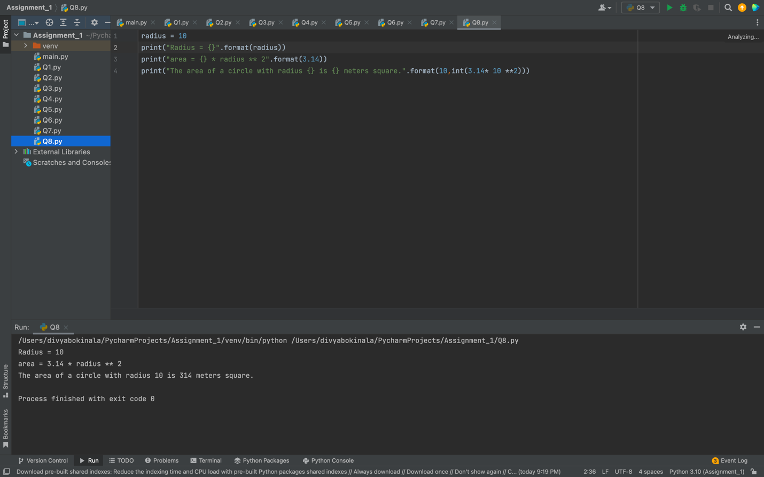

**Q9) Write a program, which reads weights (lbs.) of N students into a list and convert these weights to kilograms in a separate list using Loop. N: No of students (Read input from user)**

#Creating a list(L1) for weights(lbs) of N students

**L1=[int(num) for num in input().split(" ")]**

#Creating another list called W_kg

**W_kg=[]**

#Using for loop to iterate the values and appending the list

**for i in L1: W_kg.append(round(i/2.205,2))**

#Displaying the values in kgs after conversion

**print ("Values are:",W_kg)**

